BOYS' U.S. POLO Athletic Shoes
Boys' high top "Remsen" Athletic Shoe
from U.S. POLO ASSN. is first quality and crafted
in smooth black canvas with a vulcanized
sole, cushioned tongue, red patent faux leather
trimming and embroidered logo.
Sizes 11-3 M (638 pairs) / Sizes 4-7 M (3,600 pairs)
12 pair musical case / boxed
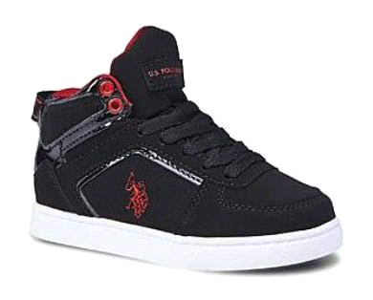

4,238 pairs

MSRP: $24.99

